Venue Location Analysis using Foursquare and other Python’s libraries

Braulio J. Cabral

Coursera

06/14/2019

Contents

Venue Location Analysis using Foursquare and other Python’s libraries 3

Introduction 3

The Dataset 3

Methodology 4

KMeans Clustering. 10

Results 17

Discussion 17

Conclusion 18

References 18

Figure 1(Data Frame of surrounding businesses) 5

Figure 2 Businesses locations and towns. 6

Figure 3 Array of businesses categories 7

Figure 4 Competitor identified using one-hot-encoding 8

Figure 5 Ward’s minimum variance 11

Figure 6 Dendrogram 12

Figure 7 Snip of data frame passed the KMeans algorithm 13

Figure 8 -Clusters with frequency means. 14

Figure 9 Features Correlation Heat Map 15

Figure 10 Kmeans Clusters 16

Figure 11 Agglomerative Clustering code 17

Figure 12 Resulting Clusters from Agglomerative Clustering 17

Venue Location Analysis using Foursquare and other Python’s libraries

# Introduction

A critical factor when opening a franchise is to determine if the location is suited for such venue. Other factors, such as distance from other franchises of the same corporation or competitor franchises are also important, as well as the need for people traffic through the location (Franchise Help, 2019). The business problem discussed in this paper relates to the need of a franchisee to validate a location for a new venue given by his corporate sponsor. Mr. John Doe received a proposed location in the town of Falling Waters, WV to open a fast food franchise. Event when the corporation’s suggestion looks appealing, he wanted to know more about the rationale, or come to his own conclusion to decide if he should proceed.

I proposed the use of Foursquare to collect a dataset of all businesses in the area and use data science techniques to analyze the dataset and see what we could learn from it. In the following sections of this paper, I will describe the dataset, the methodology and main components used in the exploratory analysis of the data and the resulting discovery.

## The Dataset

The proposed location is a small shopping center located at [39.56375, -77.887494]. The first approach in generating a data set was to map out all businesses in a 10-miles radius of this location. Businesses included all categories, competitors, such as fast food restaurants, and any other businesses that could serve similar menu items, such as small coffee shops or sandwich. places). To generate the dataset, at first, my approach was to use the above coordinates and run a single search. Unfortunately, that approach returned a number of businesses smaller than the actual number of business in the area. I then decided to list all coordinated of small towns in the area and loop through them to generate single outputs, then aggregate them into a super data frame. This approach resulted in a data frame with 368 business.

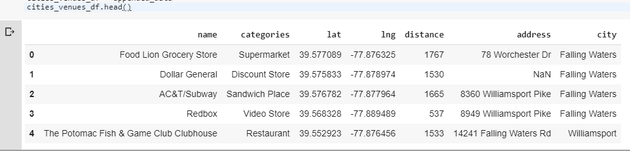

Figure 1(Data Frame of surrounding businesses)

The data frame above describe each venue as a row with the corresponding features of name of the venue, categories, latitude, longitude, the distance of the venue in relation to the proposed location, its address and the corresponding city or town. A very important feature here is the “distance” from the proposed location, for both, competing businesses, and non-competing. For competing businesses such as those of the same category as the new franchise, it will give us an idea of how strong the competition may or may not be in the proposed location, and for non-competing businesses, we can learn about the potential customers traffic in the area.

## Methodology

The first step in the exploratory data analysis of the above dataset was to produce a visual depiction of where the businesses are in relation to the proposed location. Using folium, a library the builds on the strengths of Python’s data wrangling capabilities and leaflet.js, I was able to produce a map and superimposed all businesses by their coordinates. To have a better view of where each corresponding town is, I overplayed each town as a colored circle enclosing the businesses.

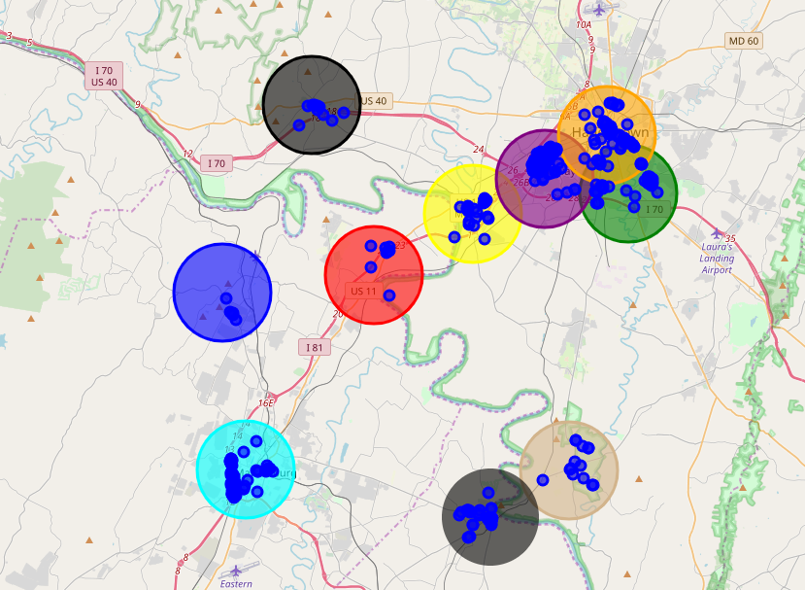

Figure 2 Businesses locations and towns.

The map above shows how the businesses are naturally clustered within the different town’s boundaries. Later, we can see if using an algorithm such as KMeans produces a similar clustering. There were 112 unique business categories identified, the array below shows each category.

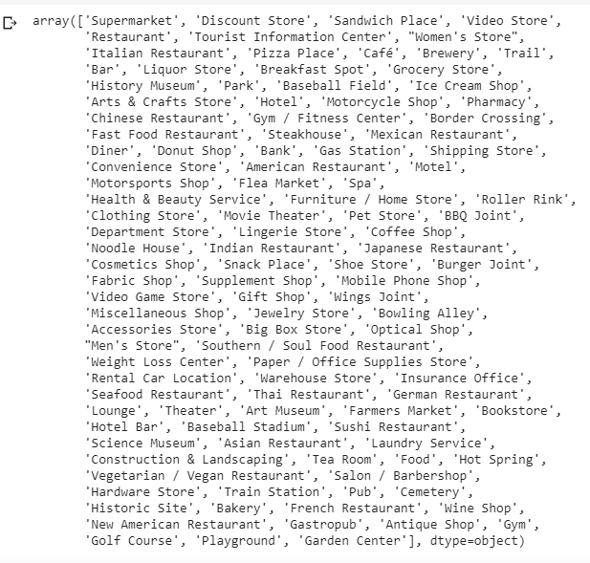

Figure 3 Array of businesses categories

As part of the exploratory data analysis, I use one-hot-encoding to group the different businesses by town, resulting in a data frame of 113 columns representing the business categories and 368 rows representing each business by town. A one-hot-encoding is a representation of categorical features as a binary vector (0 for non-present and 1 for present, in the case of the business categories). One-hot-encoding allows for a better representation of categorical data. For this problem, it helps visualize businesses considered competitors of the new franchise and those that can be potential generator of customers. For example, in the snip below we can appreciate that the town of Williamsport, MD does not have businesses that could be considered a competition to the proposed location given the fact that the franchise serves breakfast items. Of course, later in the exploration we can add the distance as a criterion to consider if this competitor is strong enough to have an impact on the new business (Brownlee, 2017).

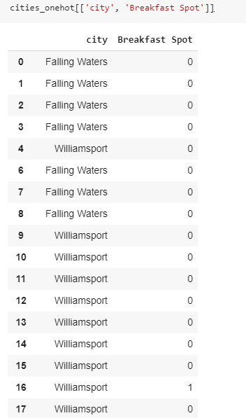

Figure 4 Competitor identified using one-hot-encoding

Another technique used to analyze the categorical data was the distribution of 10 most common venues based in their frequency for each town. In the snip below, we can see that the closest direct competitors to the fast food franchise new location are in Williamsport, Hagerstown, Clear Spring, Hedgesville, and Martinsburg, and that Falling Waters itself does not have any fast food business, making it an attractive location so far.

----Falling Waters----

venue freq

0 Women's Store 0.14

1 Supermarket 0.14

2 Discount Store 0.14

3 Italian Restaurant 0.14

4 Sandwich Place 0.14

5 Video Store 0.14

6 Tourist Information Center 0.14

7 Playground 0.00

8 Pizza Place 0.00

9 Pharmacy 0.00

----Williamsport----

venue freq

0 Trail 0.11

1 Bar 0.07

2 Café 0.04

3 Breakfast Spot 0.04

4 Sandwich Place 0.04

5 Fast Food Restaurant 0.04

6 Pizza Place 0.04

7 Grocery Store 0.04

8 Discount Store 0.04

9 Pharmacy 0.04

----Hagerstown----

venue freq

0 Fast Food Restaurant 0.07

1 Pizza Place 0.06

2 Clothing Store 0.05

3 Sandwich Place 0.05

4 American Restaurant 0.05

5 Convenience Store 0.03

6 Pharmacy 0.03

7 Discount Store 0.03

8 Ice Cream Shop 0.03

9 Hotel 0.03

----Clear Spring----

venue freq

0 Restaurant 0.11

1 American Restaurant 0.11

2 Diner 0.11

3 Ice Cream Shop 0.11

4 Fast Food Restaurant 0.11

5 Hotel 0.11

6 Hot Spring 0.11

7 Food 0.11

8 Tea Room 0.11

9 Pet Store 0.00

----Hedgesville----

venue freq

0 Discount Store 0.17

1 Convenience Store 0.17

2 Pharmacy 0.17

3 Pizza Place 0.17

4 Fast Food Restaurant 0.17

5 Italian Restaurant 0.17

6 Video Store 0.00

7 Video Game Store 0.00

8 Pub 0.00

9 Playground 0.00

----Martinsburg----

venue freq

0 Pizza Place 0.10

1 American Restaurant 0.09

2 Mexican Restaurant 0.07

3 Fast Food Restaurant 0.05

4 Hotel 0.05

5 Coffee Shop 0.05

6 Italian Restaurant 0.03

7 Gas Station 0.03

8 Sandwich Place 0.03

9 Chinese Restaurant 0.03

Table 1 – Business frequencies by towns

We then reorganize the data by sorting the cities and the most common businesses, giving a quick way to see which are the most popular and for what categories. Again, here we can appreciate that Falling Waters most common venue is a women’s store, follow by Italian Restaurant, a donut shop that could be a direct competitor to the new business is in 8th place from the proposed location.

### KMeans Clustering.

KMeans clustering is one of the easiest to understand and simplest to implement unsupervised learning algorithms used in solving clustering problems (KM, 2019). For the purpose of this paper, I used KMeans to group businesses with similarities in different groups. Remember, the similarities will be based on the data passed to the algorithms, there is no ground truth provided, that is why this is considered an unsupervised learning algorithm.

I calculated the mean of the frequency identified in the one-hot data frame and passed the new data frame of business categories frequency means grouped by towns to the KMeans algorithm. But to determine the ideal number of clusters to pass in the K argument to the KMeans algorithm, I used agglomerative hierarchical clustering algorithm. This algorithm displays a tree-like diagram called a dendrogram. The end-tail of the dendrogram represents the possible nodes or clusters based on their dissimilarity or ward’s minimum variance in this case (NCSS, 2019).

The ward’s minimum variance is calculated as the coefficients of the distance of the equation shown below.

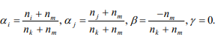

Figure 5 Ward’s minimum variance

The dendrogram suggests 10 nodes.

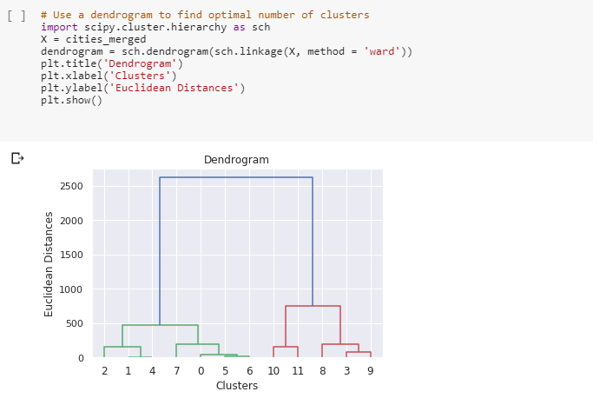

Figure 6 Dendrogram

Next, the data frame was further cleaned up to get rid of categorical data before feeding the frequency averages to the KMeans algorithm. Columns dropped included; name, categories, address, and city. Also, any rows with NaN in the latitude, longitude and distance was dropped, resulting in the data frame below.

….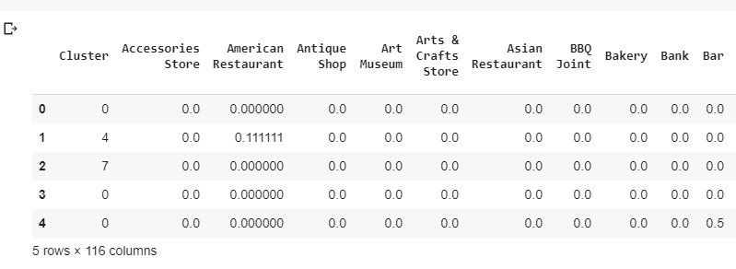

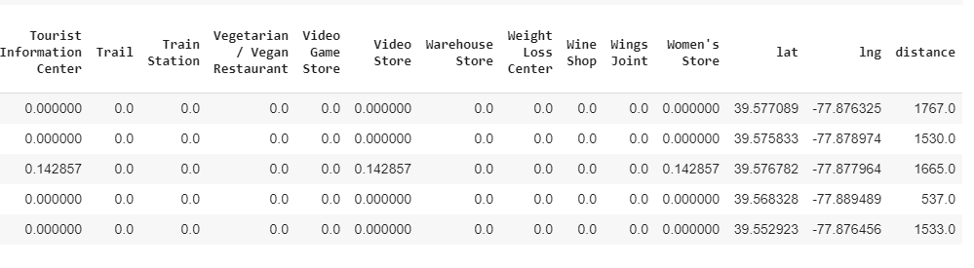

Figure 7 Snip of data frame passed the KMeans algorithm

After transforming the data using Standard Scaler to ensure that values such as distance are standardized with the rest of the data. The standardized data is represented in the snip below in the form of an array.

array([[-1.14682928, 0. , -0.62286726, ..., -0.35199567,

-0.54912253, 0.87298433],

[ 0.10425721, 0. , 2.22125218, ..., -0.44304175,

-0.63828297, 0.45704071],

[ 1.04257207, 0. , -0.62286726, ..., -0.37423699,

-0.60428096, 0.69397062],

...,

[-0.52128604, 0. , 1.20549523, ..., 1.33941722,

1.29840416, -1.41909314],

[-0.20851441, 0. , -0.02758645, ..., 0.91614473,

1.80000389, -0.46084329],

[ 0.72980045, 0. , -0.62286726, ..., 1.36460766,

1.12535163, -0.74164911]]).

Table 2. Array of standardized data

The standardized dataset was fit to the KMeans algorithm

num_clusters = 10

kmeans = KMeans(init="k-means++", n_clusters=num_clusters, n_init=12)

kmeans.fit (cluster_dataset)

labels = kmeans.labels_

Next, the clusters labels were inserted into the data frame resulting in a new data frame showing the businesses grouped by clusters. To determine the centroid values, the average or mean of the frequencies was taken for each cluster, as shown in the table snip below.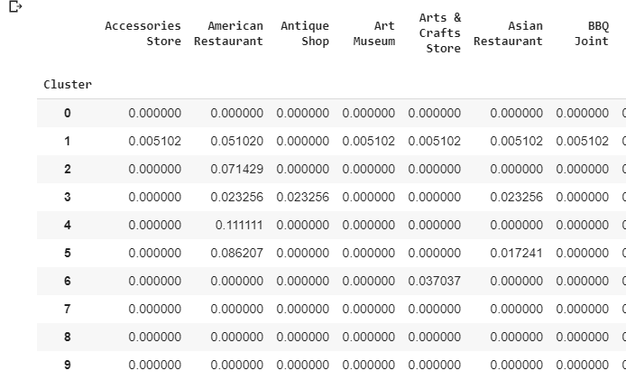

Figure 8 -Clusters with frequency means.

In order to explore the correlation between the different features, I created a correlation heat map using seaborn. Seaborn is a library use in Python to visualize data, based on matplotlib, seaborn provides an interface for drawing statistical graphics (Waskom, 2018). The generated heat map is shown in figure 9. The stronger the color, the stronger is the correlation coefficient between the two features.

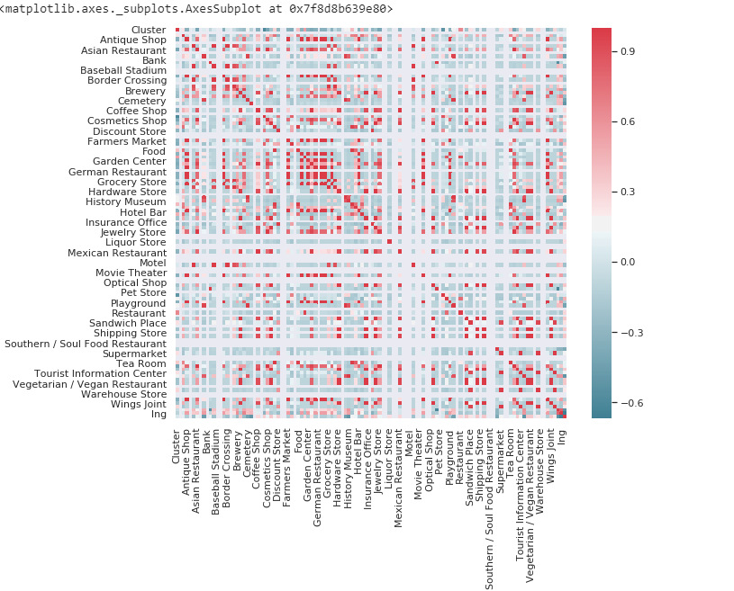

Figure 9 Features Correlation Heat Map

Finally, I plotted the clusters from the Kmeans algorithm into the map of the area and then super imposed the businesses. Unfortunately, even when the clusters match a number of the business, the clusters do not group all the businesses as closed as they were clustered or grouped around the towns when plotted in their corresponding locations. This is possibly due to needing more data or more significant correlation or that the number of iterations by the algorithm were not enough, or maybe that we need a more efficient algorithm other than Kmeans. You can see in the map below the colored spheres representing the cluster’s centroids and the surrounding businesses in dark blue circles.

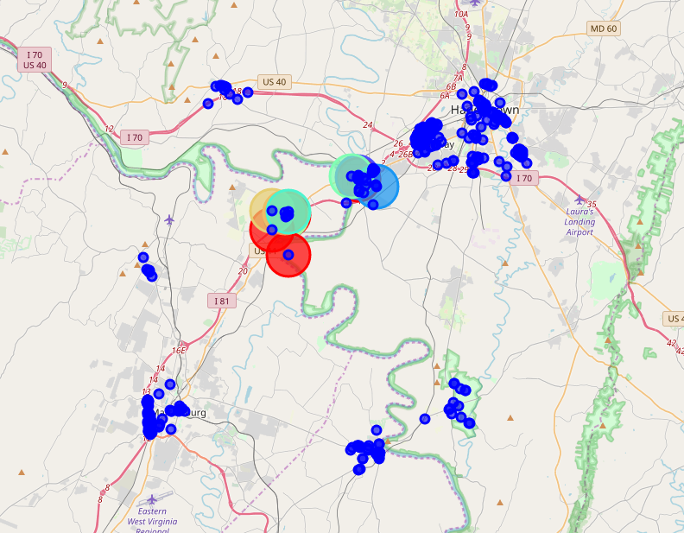

Figure 10 Kmeans Clusters

In an attempt to get better results, tried fitting hierarchical Clustering using Agglomerative Clustering, using Euclidean distance.

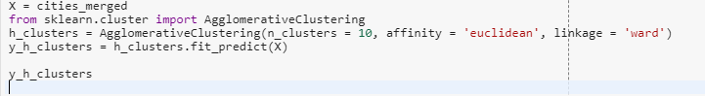

Figure 11 Agglomerative Clustering code

The resulting clusters seem to have a better distribution than the previous clusters. If super-imposed on the map, it will cover more of the business, meaning that the algorithm is more effective for the purpose.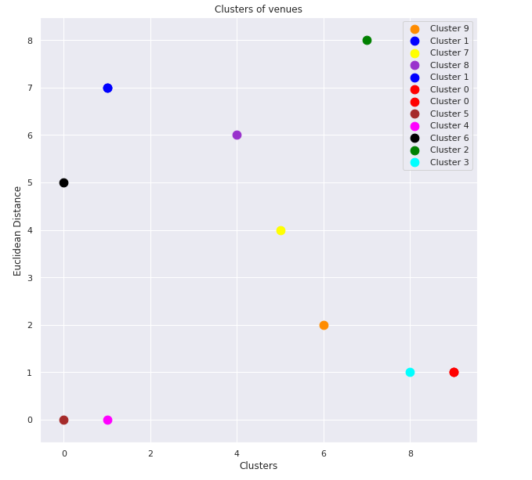

Figure 12 Resulting Clusters from Agglomerative Clustering

## Results

The resulting outcome of this exploratory data analysis is that even when the clustering may not give a definitive answer to verifying if the proposed location is ideal, the exercise provides evidence that the location has certain features that makes it suitable for the type of franchise being opened. For example, we analyzed 116 different business categories, through the analysis, it can be seen that the proposed location does not have any direct competitor and that the existing competitors are at a distance far enough as to minimize the threat. The location is surrounded by other type of businesses that will bring an inflow of people to the area creating potential customers.

Producing a correlation heat map helped us see the relationship of the surrounding businesses and determine if any of them had a high correlation to the new business. Generating a data frame with the most common businesses also helps us determine where the competitors were and also where businesses that could attract customers to the franchise are located.

## Discussion

Some observations include the fact that Kmeans algorithms are not so suitable for prediction. The labels are pretty much arbitrary and it is difficult to determine the type of businesses that are member of a particular cluster. This exercise was more geared toward data exploration, I think it can be enhanced by identifying more relevant features such as menu of competitive businesses, organize the competitors by a certain weigh based on distance, menu similarity, and even pricing. I learned a lot with this exercise, and look forward to more practice. One interesting thing I noticed is that looking for help with Python and Python libraries, becomes more difficult when you are dealing with relatively big datasets due to the fact that most examples are based on very simple Numpy generated synthetic data or data that does not necessary relate to the problem at hand.

## Conclusion

I would say that the outcome of the data exploration can help the interested audience make a decision based on more information about the surrounding area. The data exploration in itself, provides a good understanding of the type of businesses and the level of competition the new franchise should expect. Enhancing the analysis to include prediction of other possible locations would be of great interest for anyone looking to open any type of business.

## References

Brownlee, J. (2017). How to One Hot Encode Sequence Data in Python. Article extracted from URL: https://machinelearningmastery.com/how-to-one-hot-encode-sequence-data-in-python/

Franchise Help (2019). Where Is The Best Location To Open Your Franchise? Extracted from URL: https://www.franchisehelp.com/franchisee-resource-center/where-is-the-best-location-to-open-your-franchise-/

KM (2019). K-Means Clustering Algorithm. Article extracted from URL: https://sites.google.com/site/dataclusteringalgorithms/k-means-clustering-algorithm

NCSS Statistical Software (2019). Hierarchical Clustering/Dendrograms. Chapter 445. Extracted from URL: https://ncss-wpengine.netdna-ssl.com/wp-content/themes/ncss/pdf/Procedures/NCSS/Hierarchical_Clustering-Dendrograms.pdf